LOCH ACHONACHIE ANGLING CLUB

Membership Renewal/Application for completion and return by email

We look forward to you joining our club. Please complete this form with your current address, email & telephone information etc. Club news and newsletters are only emailed out so please make sure email address is correct. Thanks
*Full Name

*Address

*Post Code
*Telephone No *Email address

*Mobile No *Date of Birth …/…/…..
* Car registration
* have you checked and completed all asterisked items above Yes/No
(Admin Use: Allocated membership number) :
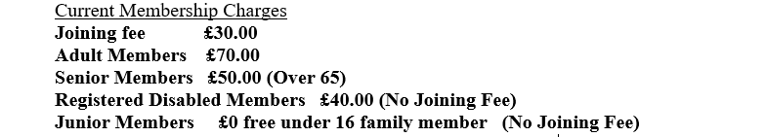Main Fishing Interests Salmon/Brown Trout/Both
Please delete Yes/No below as appropriate.
All members should read the club Safe Fishing leaflet and agree to follow that advice
Do you have a copy of the rules of this club? Yes/No
Are you a member of another fishing club? Yes/No
If so which one ? ……………………………………………………..
Have you ever been refused Fishing Club Membership or Permit? Yes/No
Have you ever had your Membership of any Fishing Club Withdrawn? Yes/No

I have read and fully understand the rules of the Loch Achonachie Angling Club and agree to abide by them. I understand if I am found in contravention of any of these rules, my Membership may be withdrawn. I agree to submit a completed catch return by end of October each season.

*Please find enclosed the sum of £…………

Signature ……………………………… Date …………………………

*Postal renewal: cheques should be made payable to “Loch Achonachie Angling Club”.

Return completed with payment to Chairman, LAAC, Errigal Lodge, Chanonry Crescent FORTROSE IV10 8RH
*For payment by BACs see below or contact achonachie.angling@gmail.com

BACS DETAILS FOR ONLINE JOINING
Royal Bank of Scotland 83-18-01
A/C LOCH ACHONACHIE ANGLING CLUB 00122465
Email this form completed to the Stephen Dowds at achonachie.angling@gmail.com with note of your BACS payment - please use your name in your bank’s reference entry – if you are renewing as a member from last season please include your usual membership number

